VISION

To inspire, empower, and nurture every child entrusted to our care.

MISSION

Our Nazareth House family work in faith, with the child at the heart of everything we do. Our mutually supportive collegiate approach draws us together in building an optimal learning environment wherein every member of our school community feels safe, at peace, and ready to learn and grow. Our core values, rooted in the Gospel, support our school family to serve the common good of society. We teach our children to be compassionate and forgiving, to celebrate diversity with tolerance and respect, to be people of hope and aspiration, and to be resilient in an ever-changing world. Through inspiring teaching, we enable our children to reach their academic potential, unlocking the doors to their success.

All young people, from whatever background, have a right to be valued and respected, to be educated in a secure and caring environment, and to have their abilities and talents nurtured and developed to their full potential.
(DOE: Pastoral Care in Schools –Promoting Positive Behaviour)
Article 3
The best interests of the child must be a top priority in all actions concerning child.
(Article 3 UNCRC)

CONTEXT
- Nazareth House Primary School and Nursery Unit is a Catholic school on the banks of the River Foyle, in the heart of Derry City.
- Within our beautiful historic building, itself a legacy and reminder of the nurturing principles of the Sisters of Nazareth, we meet the needs of between 200 and 250 pupils from a range of backgrounds and with a diversity of needs.
- We are committed to promoting the best interests and wellbeing of our close knit community; children, educationalists and parents.
- Our Policy [2023] is built on the wealth of information available to us on how our experiences impact upon brain development and our ability to regulate and manage our own behaviour. We understand the need to employ methods that support our pupils in learning to resolve the need underlying their behaviour.
- We are moving from Managing Behaviour to Nurturing and Supporting our pupils to manage their own behaviour.

ETHOS

- The staff aim to create a safe climate which enables effective learning and teaching to take place, within relationships of mutual valuing and respect.
- We believe education should provide for and equip all our children with the skills and values necessary to make a positive contribution in a changing world.
- Nazareth House Primary School wants children to be self-motivated and to be at peace with themselves, others and the world.
- We actively seek to promote inclusivity for those pupils with additional SBEW needs.
- To achieve these aspirations, the school requires the help, commitment and co-operation of children, parents, staff, governors and the wider community.

Aims of the policy

At the core of SBEW needs is often stress, anxiety, lack of self-worth/low self-esteem and fear of failure. At some point in their Primary school life SBEW could be an area of need important to every pupil. Our staff team in Nazareth House Primary School will continue to use our experience and expertise to support pupil needs. Whole class planning, in line with Article 3 of the 1998 Education Order, will focus on developing effective learning behaviours such as listening attentively, critical thinking, decision making, repair and responsibility and/or inhibition. Where necessary teachers and class teams will make additional plans to support specific needs when pupil behaviour is a barrier to effective learning and teaching.

The main objectives of our Behaviour Policy are:
-To outline what is expected from all our pupils, staff, and parents in terms of behaviour.
-To outline how we plan, target, and implement support for those with additional SBEW needs.
-To outline how we work as a whole school community to understand, nurture and support the social, emotional, behavioural and wellbeing needs of our pupils.
-To foster a whole school ethos that is designed, built, and maintained with a commitment to understand and support all our pupils, parents, and colleagues in an atmosphere of collective care.
-To identify, understand and be sensitive to the fact that Social Behavioural and Emotional Wellbeing (SBEW) is a unique special educational need in that it is likely that many members of our school community will experience need in this area at some point in their lives.
-To recognise that additional needs in this area, however severe, do not need to be long term and should not carry shame.
-To promote an ongoing whole school ethos that adopts strategies and procedures firmly built on Trauma informed practice and the principles of Nurture.
-To promote the development of, and emphasise the need for, strong positive relationships and a sense of belonging for all within our whole school community.

RIGHTS AND RESPONSIBILITIES

Our community works in partnership to ensure that behaviour conducive to learning and quality teaching is the baseline norm.
All members of the community can expect inclusion and respect.
All members of the community have a responsibility to behave inclusively and respectfully towards each other; governors, visitors, staff, pupils, and families.
At times it may be necessary to take purposeful measures and/or make reasonable adjustments to our practice to accommodate the needs of some members of the community.
Parents and, at an appropriate level, pupils will be included in planning and decision making in such instances.

The best interests of our pupils will always be at the heart of our planning and support.

We work closely with EANI’s Primary Behaviour Support Service, Educational Psychology and Other Support Agencies and Organisations, including Social Services, to ensure the best possible provision is made for our pupils with Additional Needs.

What is expected from all pupils, staff, and parents in terms of behaviour?

Behaviour within Nazareth House P.S falls into four broad categories defined as follows:

APPROPRIATE: We behave responsibly and conform to the agreed charters and values of the school. This behaviour is recognised and praised. This behaviour allows quality learning and teaching for all to progress.

Additional MILD: We occasionally disrupt or disrespect but respond positively to the planned responses and repair procedures in place.

Additional MODERATE: We are in-appropriating behaviour more frequently and are not responding to repair procedures.
A Personal Learning Plan may be required to support progress back to responsible, respectful, considerate and safe behaviour. This plan may support implementation of strategies within the classroom to support pupils to succeed.

Additional SEVERE: A range of additional supports may be required and pupils may be placed on the Register of Special Educational Needs to allow planning for success and monitoring of
- additional resources within school being targeted towards the needs
- support from external agencies to assist in meeting the needs
- pupils being educated away from the main group for periods of time during the day/week to enable additional support or specific bespoke programmes of study to be delivered
- aspects of the main curriculum being adapted and or disapplied to enable Needs to be prioritised

How we plan, target, and implement support for those with additional SBEW needs
Behavioural Needs are managed inclusively at Nazareth House school and are subject to similar procedure and practice as any other area of Special Educational Need such as learning, language and or medical needs.
Assessment, Planning and Monitoring of progress in respect of these needs and in line with The Code of Practice for the Identification and Assessment of Special Educational Needs is followed.
Stage 1: additional support from class teacher and from within the existing resources of the school.
Stage 2: additional support from outside the school from EA and Health and other services and organisations.
Stage 3: an evidence-based assessment of the need for additional and sustainable statutory provision to be made as needs cannot be reasonably met without these.

PROFESSIONAL LEARNING:

At Nazareth House we worked together as a staff to agree our VALUES during directed time, May 22 to October 22 supported by EA PBSP, and again during May and June of 2023 to agree the final draft to share with parents September 2023.

Our values are reflected in the above context, ethos, aims and responsibilities sections of this policy.

Responses to Appropriate Behaviour in our school will be inclusive and achievable to all;

APPROPRIATE: We behave responsibly and conform to the agreed charters and values of the school. This behaviour is recognised and praised. This behaviour allows quality learning and teaching for all to progress.

At Nazareth House we recognise the difference between affirmation and reward that all children are ENTITLED TO because they are part of our community and REWARD and praise for consistent best effort or a specific achievement.

All children are ENTITLED to affirmation but REWARDS are earned.

CATEGORY | ENTITLEMENT | REWARD
Within Class Daily | Praise, encouragement, positive reinforcement of appropriate behaviours. | Marbles, table points, stickers, individual chart stickers, Dojo points
Within Class Weekly | Golden Time | Star of the Week certificate  Mathletics/ A.R certificates.
Within Year Group | Recognition in assembly of class groups who show appropriate behaviour in different settings or are noticed by someone outside our school community. | Sent to KS coordinator or other teacher or principal for reward for excellence.
Within Whole School | Facebook – celebrations of achievements. | Assembly acknowledgement  Facebook  Yearly Prizegiving
Additional / Incidental |  | Being trusted with a ‘special’ role – guiding a visitor, distributing notes/ registers etc.  Good news notes from teacher/ KS coordinator/ VP/ Principal.

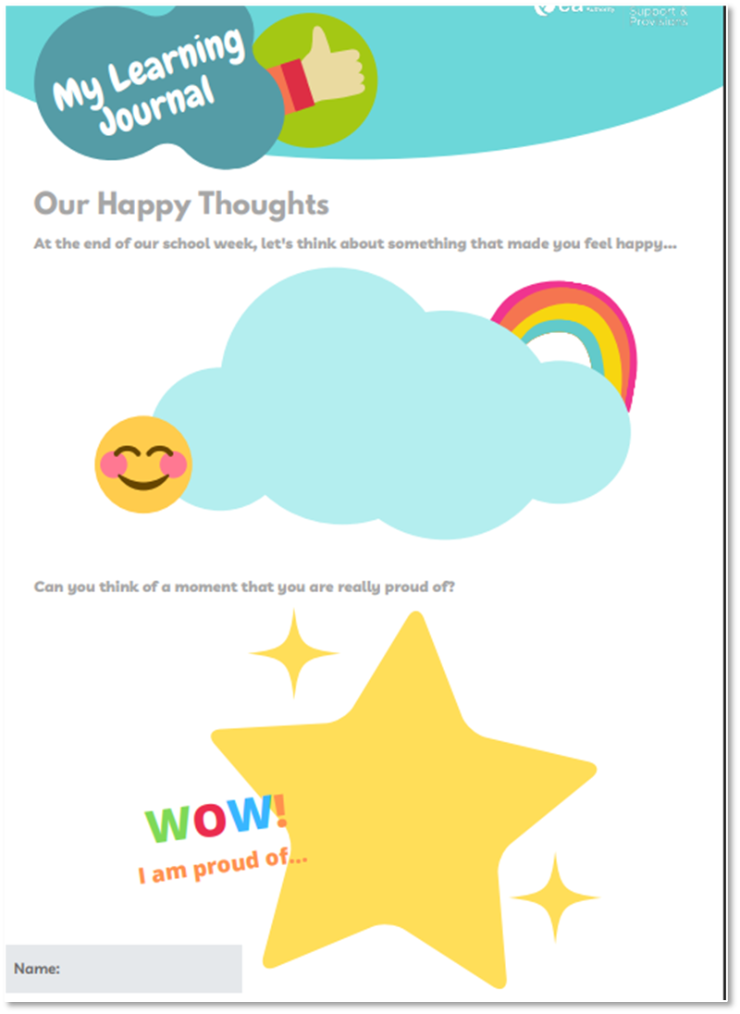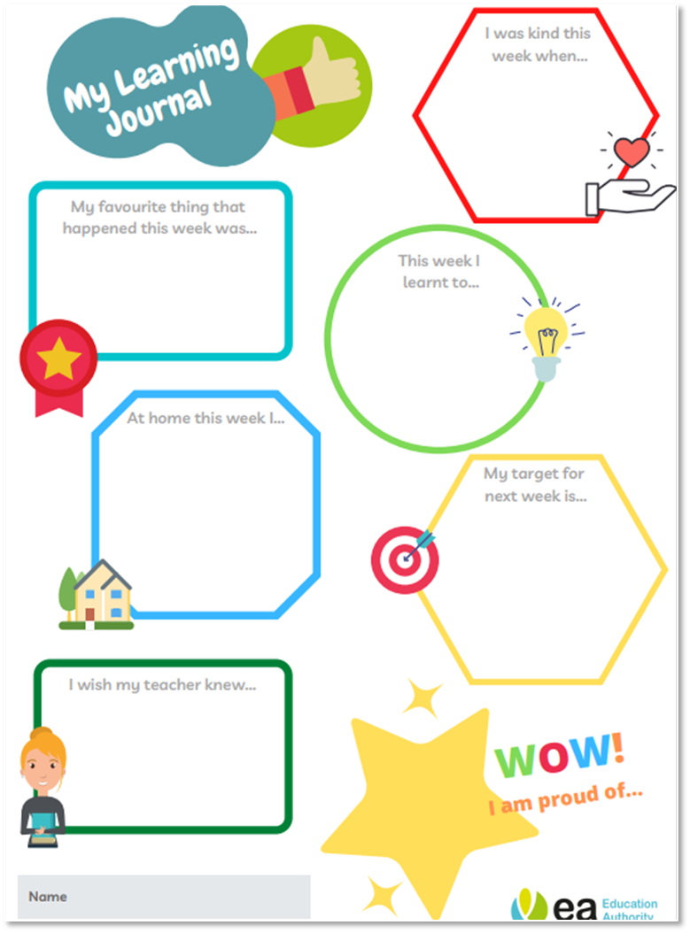

Responses to Additional Needs Behaviour in schools must respect children’s human dignity (Article 28, UNCRC)

We believe that strategies and interventions adopted should be firmly built upon
- Trauma Informed Practice
- The Principles of Nurture
- The 4 R’s

The cornerstone to any approaches to understanding and supporting SBEW is strong positive relationships within the whole school community with a sense of belonging for all.

Our approach at Nazareth House PS is to apply these values to our Learning and Teaching across all Curriculum Areas Including the Behaviour Curriculum

The whole school community is committed to building and maintaining positive relationships.

The pupil’s voice is valued, listened to and is central to reflective practice. All young people have something to say but not all young people have the language to express what they need to say.
We can only express verbally what is emotionally manageable and for some young people behaviours are nonverbal communication which we need to learn the language of.
Adults must have a commitment to understand and listen to their pupils.
Pupils must feel noticed, heard, and understood.

The pupils are given choice and opportunities to develop in their independence—school is a safe place to make mistakes.
Accepting each young person where they are developmentally leads to a safe place to make mistakes. Our responses reduce tension and lead to new learning.
Young people are given space to make plans and track their own progress rather than comparing themselves with others.
There is no toxic shame associated with making mistakes.
Young people are intrinsically motivated to learn, rather than hooked on external approval.

The 6 Principles of Nurture
Ref: Lucas,S., Insley,K. and Buckland,G. (2006) Nurture Group Principles and Curriculum Guidelines Helping Children to Achieve

- Pupil's learning is understood developmentally. Staff respond to pupils at their emotional/developmental level; not the expected academic level.

Staff will:
Ask WHY if a pupil is not succeeding and assess and explore further
MONITOR and keep notes and if needed observations.

Parents will:
Share relevant developmental experiences and concerns about their children with class teachers who will ensure SENCo and pastoral lead are aware when necessary

Pupils will:
Always try their best to do what is asked of them

- The classroom offers a safe base reflecting what we know about the importance of structure and predictability. Adults are reliable and consistent in their approach—working together supportively. Adults recognise the link between emotional containment and cognitive learning. Relationships are key. We need to feel safe and to trust our environment and the people around us to progress.

Staff will:
Be consistent, be open and available when needed - LISTEN
Be fair
Providing ‘objects (soft toys) that make children feel safe – class mascot

Parents will:
Work with school staff and reassure children that school staff will help them and should be trusted

Pupils will:
Adhere to school rules and ethos to ensure the safety and wellbeing of others.

- The importance of nurture for the development of Self Esteem.
Listening and responding to pupils, showing they are valued and thought about and kept in mind.
Understanding the young person’s internal working model of themselves, others and the world.
Recognising their view of themselves
Creating a safe place to make mistakes.
They know their next steps, how to move forward and improve.
They feel their voice is valued and worthwhile.

Staff will:
Create time and space to hear the children’s voices through Connect and Nurture/ Circle Time
Give the children a voice through student council
Celebrate all children’s achievements and successes
PASS test

Parents will:
Celebrate and value their children’s experiences/ achievements in school and at home. Check homework diaries for notifications

Pupils will:
Celebrate the achievements of their classmates and be happy for others.

- Language is a vital means of communication
Language is more than words, it is a way of putting feelings into words (body language, eye contact etc)
Pupils are helped to understand and express their feelings
Language has to be heard, used, practiced and relevant to the situation. Modelling of nurturing relationships; respectful, consistent and positive interactions.
Language used by adults is consistent with nurture, so that all are supported to feel

Staff will:
Use respectful language, language of belonging/ care. Calm, reassuring tone.
Consistent language across all classes (informed by PBS&P resources)

Parents will:
Use respectful language, use the language of school.

Pupils will:
Use respectful, calm language – use words instead of actions to express feelings.

- All Behaviour is Communication
Given what I know about this young person and their development, what
is this pupil trying to tell me? If a young person senses that their feelings
are understood this can help to diffuse difficult situations.
Understanding what a pupil is communicating through behaviour helps us
to respond in a firm but non-punitive way
We need to feel safe, to trust our environment and the people around us
so we can develop new modes of behaviour
We are aware of the relevance of pupil’s non-verbal language. We are
attentive and attuned to it
We are aware of our own emotions and how this links to our
communication behaviour – AND subsequently how this can impact a
pupil’s behaviour
The function of negative behaviour is understood. The overall approach
should aim to be restorative “in essence”

Staff will:
Respond calmly and listen attentively. Acknowledge the child’s feelings and tell them you’ll help.
Explain the natural consequences of their behaviour - how they are impacting on others.
Staff will offer alternative ways for children express their feelings (other than verbally)
Teachers will model effective communication and talk about the outcomes of making poor/ good choices.

Parents will:
Communicate openly with staff about factors that may be influencing their children’s behaviour.

Pupils will:
Try to communicate effectively and with control where possible.
In reflection, acknowledge that they have choices in how they express themselves and take responsibility for their choice.

Language is Communication
You belong here.
You are welcome here. I like you.
You are safe here.
Your feelings are okay with me.
You can explore and learn.
You can work with me. l will be thinking about you, and
keeping you in mind.
I believe in you

- We recognise the importance of transition in our pupil's lives. Staff acknowledge the feelings aroused by transitions and understand that even small changes in routine (e.g. coming to school, unstructured times, a visitor, a supply teacher,) can be overwhelming and unsettling for some young people.

Staff will:
Have a timetable so that children will know when a transition is imminent.
Be present throughout transitions where possible, reassuring children where necessary.
Keep process of transition consistent
Where necessary, prepare the class and allocate time (or individual children) for transition (hourly, daily, yearly transitions) .
Allow transition objects where appropriate.

Parents will:
Prepare and support their children for transitions
Parents will engage with materials provided for transition by school staff.

Pupils will:
Adhere to school rules
Communicate calmly

RULES AND PROCEDURES
Rules and procedures should be designed to make clear to the children how they can achieve acceptable standards of behaviour.
Rules differ from procedures.
Procedures are taught routines which create a safe learning environment
Rules are a guide to success in learning and school life.
Rules are simple and easy to remember phrases; flexible enough to be relevant and applied in different places and activities.
At Nazareth House PS we believe that rules should:
- be consulted, agreed and shared amongst all parties
- be kept to a necessary minimum;
- be positively stated, telling the children what to do rather than what not to do;
- actively encourage everyone involved to take part in their development;
- have a clear rationale, made explicit to all;
- be consistently applied and re-enforced;
- promote the idea that every member of the school has responsibilities towards the whole and to themselves.
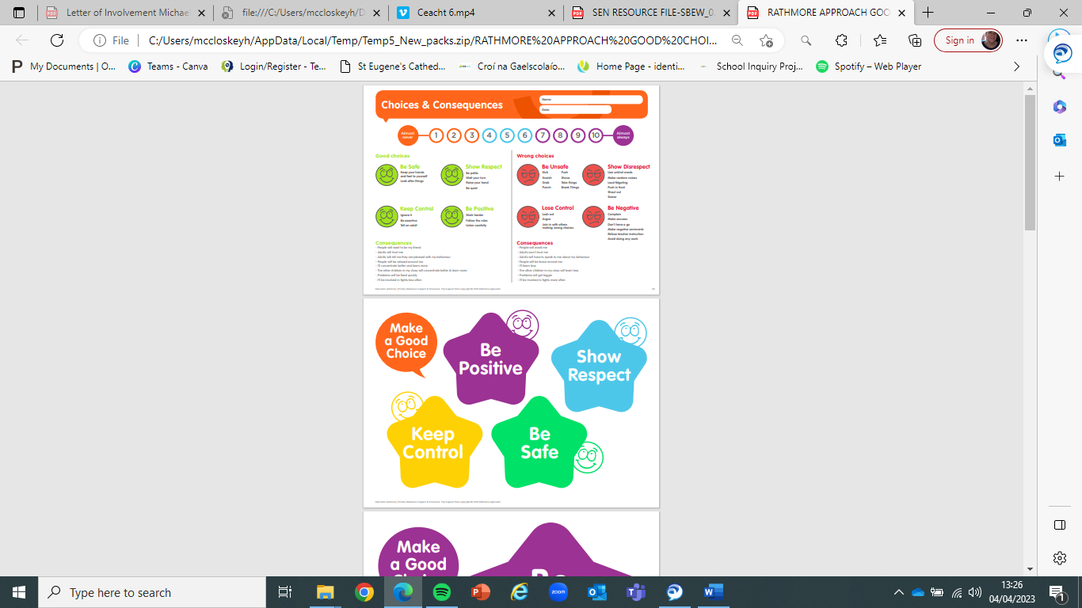

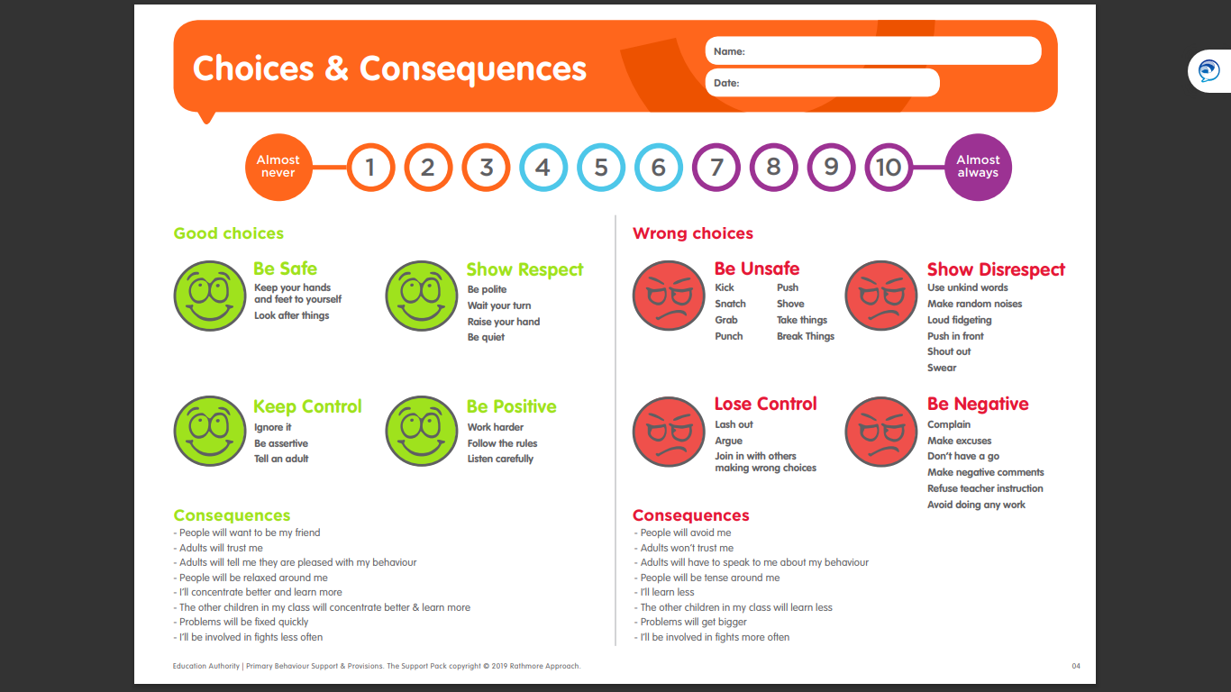

Rule | Eg for use in the classroom | Eg for use in the canteen | Eg for use in the playground | General use
Be Safe | Walk  kind hands  Careful hands and feet  Follow instructions  Careful use of equipment (chairs/ scissors)  Keep environment tidy – everything in its place | Stay seated until you are dismissed  Line up in an orderly way and keep both feet on the ground  Use cutlery safely and appropriately  Eat only your own food.  Wait patiently | Stay in your own play area  Use equipment safely and responsibly  Move around safely – be aware of people around you.  kind hands  Careful hands and feet  Line up in an orderly way and keep both feet on the ground | Walk quietly at all times inside the school building  Make sure an adult always knows where you are at all times.
Show Respect | Listen to eachother  Always use manners  Care and share  Look after resources carefully | Take care of your own other’s property  Put all litter in the bins  Speak to eachother with kindness and respect, use manners. | Listen to and follow instructions from school staff  Greet adults and visitors with manners and respect | Greet adults and visitors with manners and respect
Keep Control | Use your words to express yourself  Ignore  Use a trusted adult | Use your words to express yourself  Ignore  Use a trusted adult  Ask to move seats | Play safely and with NO HURTS  Walk away  Use your words to express yourself | Use your words to express yourself
Be Positive | Greet eachother  Work hard  Greet adults - Good morning/ good afternoon  Say please and thank you | Greet eachother  Work hard  Greet adults - Good morning/ good afternoon  Say please and thank you | Move aside to create space when needed  Be mindful of others  Invite and include others in your games | Wear your school uniform with pride  Be kind and helpful  Greet eachother  Work hard  Greet adults - Good morning/ good afternoon  Say please and thank you

Pupils with SBEW Needs will
- have difficulty in the development of their social, behavioural, emotional skills and well-being.
- may have immature social skills and find it difficult to initiate and sustain healthy relationships which is impacting on their learning and progress in school.
Expectations
- We come to school ready for work
- Be punctual at all times
- Be ready for lessons - homework done and books out, prepared to start as soon as the teacher begins
- Clear up - after lessons, break, lunch
- Respect the environment - classrooms, toilets, furniture, equipment, playground, trees, plants etc.
- Play fairly.
- Respect everyone’s rights and authority.
- Be courteous to visitors to the school.
- Co-operate with teachers at all times.
Parents can support their children by

All children and young people have the right to a primary education, which should be free… Young people should be encouraged to reach the highest level of education they are capable of (Article 28 UNICEF UK).

If children have the right to be educated, then they have the obligation to learn as much as their capabilities allow and, where possible, share their knowledge and experience with others. Education must encourage the child’s respect for human rights, as well as respect for their parents, their own and other cultures, and the environment. (Article 29 UNICEF UK).

When Things Don’t go to plan we support by:

While a positive system of rewards and reinforcement will attempt to guide children towards self-discipline, it is important that strategies exist to assist staff in dealing with challenging and disruptive behaviour. To assist staff, we in Nazareth House P&NS will employ a positive behaviour management strategy using stepped consequences. These consequences are an integral part of our School’s Positive Behaviour Management Policy. They help to uphold the agreed rules, they provide the security of clearly defined boundaries and, in doing so they ensure that all are fully aware of the conditions which will lead, in all likelihood, to the imposition of consequences.

The agreed stepped consequences offer a sliding scale of intervention in the pupil’s behaviour requiring the pupil to take more responsibility for his/her own actions.

While these agreed consequences are stepped,
if a pupil puts himself/herself or others at risk, staff can fast-track the stages by notifying the
Principal/Vice-Principal and contacting the child’s parents without delay.

Where possible, staff will bear in mind that prevention and intervention are crucial to managing conflict situations. As a result of the children considering their rights and responsibilities the following consequences were drawn up in consultation with the children and will be used by staff in a fair and consistent manner in order to diffuse a potentially difficult situation by encouraging pupils to reflect on their behaviour and to take more responsibility for their actions:

REDUCING BARRIERS TO LEARNING
Nazareth House P.S & N.U staff are advised to understand and respond to individual behaviour through the trauma informed approach shown below:
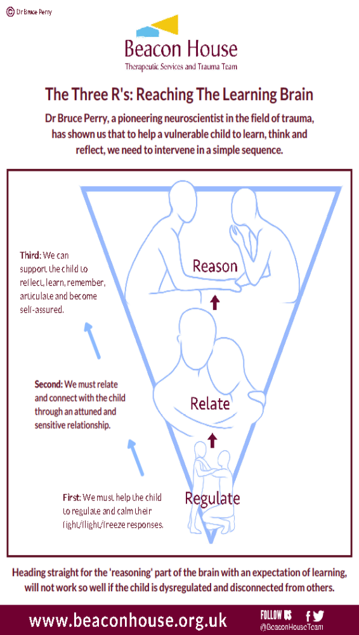What do staff do when the young person’s brain is responding in a way that has triggered the alarm state? We use the 3R model to help a young person to:
Regulate: Reduce feelings of stress and anxiety
Staff to enable the young person to feel safe will focus on reducing tension and providing reassurance. At this stage staff will say very little to give a young person space and time.
Relate: Connect
Staff will ensure the young person knows they are cared for and loved so the focus is on connecting with them, for example by showing an interest in them by sharing a happy memory.
Reason: Reflect, look and learn
Now the young person is able to talk about what happened. Staff will talk about alternative ways to manage these emotions when they come.
Until the young person is regulated they won’t be able to relate and until they relate and are connected to you they won’t be able to reason and talk about what happened. When you see a young person begin to struggle, take notice and recognise which R they need right now. It’s important to respond to the young person where they are at. This allows for genuine processing and learning from the incident and a reduction in the likelihood of repetition in the longer term. It also reduces the risk of retraumatisation.
Note:
- Where is the pupil is at?
- What support are they ready for right now?
Be patient, it can take a while before the young person is ready to talk about what happened. Sometimes it may be the next day.
Try in so far as it is reasonably possible to begin every day as a fresh start. This will model for children how to repair and rebuild.

Guidelines for establishing bespoke individual support plans:
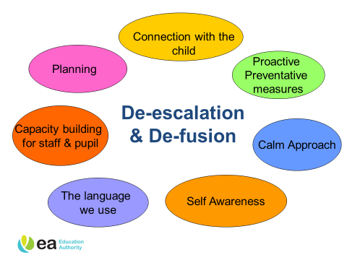
The voice of the child must be central to this process. The plan is done not to them or for them but with them. To establish the child’s perspective the pupil voice can be captured through individual dialogue or group discussion. We want children to be clear about what might help them. The dialogue with the pupils must be open and solution focused.
Staff will use open restorative questions such as those detailed here to help them look, link and learn from the experience:
- Tell me what happened?
- How did you feel about?
- What were you thinking at that time?
- What did you choose to do then?
- How did your actions make others feel?
- What different choice could you make next time this happens?
- What do we think we might need to do now to help make things better?
- Would it help if I ……, Would it help if you…. Would if help if we …….?
- Can you finish this sentence for me….? It would help if….
- Tell me what behaviour you would like to change.
To identify which type of therapeutic support is best suited to an individual child’s needs, staff must use discussion with children, Ed. Psych. recommendations and the core assessments for SBEW

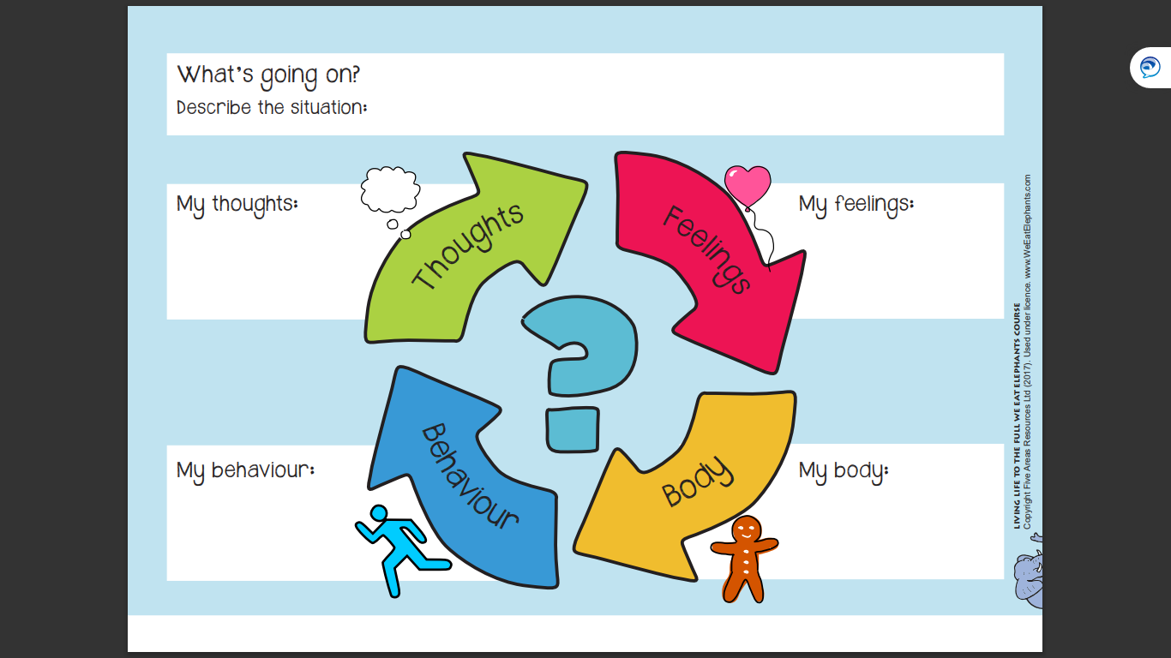

We teach that the main consequence of inappropriate decision making and response to any strong and powerful emotions we may be feeling, is to ourself. Wellbeing and a Healthy Sense of Belonging and Accomplishment are experienced via appropriate behaviour.
We emphasise the importance of taking the responsibility to put things right.
We focus on the real consequences of any inappropriate actions.
DID THAT MAKE THINGS BETTER OR WORSE?

Communication with Parents

In order to promote positive behaviour in our school and maximise the effectiveness of the school’s Positive Behaviour Management Policy, we welcome continued parental involvement and support. To this end, the school will issue annually to parents and carers, information about the school’s Pastoral issues, e.g.
policies on Child Protection, Anti-Bullying, Positive Behaviour Management etc.

At the beginning of each school year class teachers will inform parents and carers of their Positive Behaviour Management Classroom Plan outlining all rights and responsibilities. In turn parents/Carers will discuss this with their child and return the signature slip to school.

The Role of the Board of Governors

The Board of Governors fully supports the school in the implementation of the school’s Positive Behaviour Policy, and will be kept informed of policy updates and relevant circulars relating to behaviour management.

Policy Monitoring and Review

- This Policy should be read in conjunction with Special Educational Needs Policy, Learning and Teaching, Assessment, Child Protection, Safe Handling and Safeguarding Policies.
- Safeguarding should permeate all aspects of school life.
- To be reviewed 2025.
- Assessment Tools in school at present we work with PBSP where necessary to assess a pupils progress within the behaviour curriculum using the following tools. Staff are supported in this initially by EA PBSP Team Members in relation to referred pupils.
Boxall Profile
Readiness for Integration
Strengths and Difficulties.

Area for Development

The use of assessment for behaviour monitoring tools and implementing class-based strategy will be monitored 2023 to 2025.

Stepped Consequences
Reminder

Verbal Counsel

Second verbal counsel
(This may be recorded in incident log
book/ child’s homework diary/
The agreed stepped consequences offer a sliding scale of intervention in the pupil’s behaviour requiring the pupil to take more responsibility for his/her
own actions.

*Please note,
if a pupil puts himself/
herself or others at risk, staff can fast-track the stages by notifying the
Principal/Vice-Principal and contacting the child’s parents without delay.

phone call to parent/note sent home)
Consequence applied.

Parent invited to meet
teacher to agree improvement
plan. (Principal/V.P may be
involved at teacher’s discretion).

Vice-principal/ Principal informed who will
put the child on a daily report
and inform parents via
phone or letter.

Principal informed who will meet
with child/teacher/VP as necessary,
formally recorded, parents informed of this via
phone or letter.

Principal meets with parents.

SENCO
SENCo support does not rule out Detention, Suspension, or Expulsion.
DETENTION

Support
SUSPENSION

Psychologist/ Outreach/ EWO EXPULSION

Procedures for Dealing with Bullying

Report of an incident/concern

Talk to pupils involved – aim for resolution
at class level using strategies e.g.
Circle Time / another child or small group of children befriends and supports the child being bullied during the school day

Child Protection Leader informed –
record made of concerns. Parents informed
and made aware of procedures

One week’s observation of children
in different settings

Parents invited to school to discuss
action taken

Continue to monitor children’s behaviour

Where possible, staff will bear in mind that prevention and intervention are crucial to managing conflict situations. As a result of the children considering their rights and responsibilities the following consequences were drawn up in consultation with the children and will be used by staff in a fair and consistent manner in order to diffuse a potentially difficult situation by encouraging pupils to reflect on their behaviour and to take more responsibility for their actions:

Communication with Parents

In order to promote positive behaviour in our school and maximise the effectiveness of the school’s Positive Behaviour Management Policy, we welcome continued parental involvement and support. To this end, the school will issue annually to parents and carers, information about the school’s Pastoral issues, e.g.
policies on Child Protection, Anti-Bullying, Positive Behaviour Management etc.

At the beginning of each school year class teachers will inform parents and carers of their Positive Behaviour Management Classroom Plan outlining all rights and responsibilities. In turn parents/Carers will discuss this with their child and return the signature slip to school.

The Role of the Board of Governors

The Board of Governors fully supports the school in the implementation of the school’s Positive Behaviour Management Policy, and will be kept informed of policy updates and relevant circulars relating to behaviour management.

BEHAVIOUR MANAGEMENT PROCEDURES

BEHAVIOUR CATEGORY | EXAMPLES | INDEX OF PROCEDURES STEPPED REWARDS
APPROPRIATE | Good timekeeping, attendance, wearing school uniform  Being prepared for school; PE gear, pens and pencils  Acceptable noise levels  Attentive to teacher and other pupils.  Settle to work quickly.  Staying on task.  Work completed to one’s best ability.  Raise hand for teacher’s attention.  Respecting the opinion of others.  Accepting constructive criticism.  Respect for property.  Taking care of building, furniture, belongings-personal and others.  Adhering to accepted conventions.  Displaying courtesy to all in school – adults and children.  Accepting responsibility for own action.  Follow all classroom/school rules. | CLASSROOM BASED  Verbal acknowledgments  Non verbal praise from teacher and peers.  Positive written comments on work.  Stamps, stickers, star chart  Class clap  Position of Responsibility  Access to computer.  Awarding of Dojo points.  YEAR GROUP/KEY STAGE BASED  Celebratory visit to Key Stage Coordinator.  Assembly recognition, Star of the Week, applause  Wider Position of Responsibility  WHOLE SCHOOL BASED  Principal/Vice Principal Awards  Star of the Week Award  Attendance Certificate  Public Recognition

BEHAVIOUR MANAGEMENT PROCEDURES

BEHAVIOUR CATEGORY | EXAMPLES | INDEX OF PROCEDURES STEPPED CONSEQUENCES
ADDITIONAL MILD | Shouting out in class  Inappropriate movement  Inattentive behaviour  Seeking attention  Late coming causing disruption  Lack of proper materials  Homework incomplete  Inability/reluctance to tidy up  Occasionally breaking classroom rules  Defacing/damaging text books.  Throwing things.  Distracting others  Tale-telling (where deemed inappropriate/ malicious)  Unkind comments.  Interrupting when other adults are talking to teacher.  Inability to share and take turns.  Lack of basic manners.  Showing lack of respect for adults.  Inability to line up properly.  Rowdy, noisy behaviour on stairs and corridors. | *REFUSAL TO COMPLY WITH A CONSEQUENCE WILL RESULT IN AUTOMATIC PROGRESSION TO THE NEXT STEP.  CLASSROOM BASED  Rules reminder  Verbal Counsel (teacher discusses with the child the impact his/her action has on others)  Second verbal counsel and consequence applied eg.:  Detention at breaktime/lunchtime for Key Stage 2 pupils. Partial loss of outside play at break/ lunch, e.g., 5 minutes.  Loss of privilege for Key Stage 1 pupils, e.g., 5 minutes of playtime.  Note home to parents.  Traffic lights for golden time, amber is a warning, red is a partial loss.  KEY STAGE / SCHOOL BASED  Counsel and short time out with K.S coordinator.  Referral to Vice-Principal if behaviour continues.

ADDITIONAL MODERATE | More frequent displays of inappropriate mild behaviours.  Low level stealing.  More frequent breaking of school rules.  Rough play.  Lack of application to school work.  Leaving classroom / school without permission.  Inappropriate behaviour in toilets – toilet roll thrown in toilets.  More serious verbal comments to others.  Backchat to teachers.  Telling tales to get others in trouble.  Flicking food in canteen.  Defacing school property.  Persistent defiance. | Procedures as outlined for inappropriate mild behaviour.  Referral to Vice-Principal/Principal.  Contact with parents.  Daily report (one week)

BEHAVIOUR CATEGORY | EXAMPLES | INDEX OF PROCEDURES STEPPED CONSEQUENCES
ADDITIONAL  SEVERE | Abusive language to adults and children.  Vandalism / destruction of property.  Threatening behaviour.  Persistent defiance after constant checking by teacher.  Physical assaults.  Cursing to children and adults.  Bullying.  Serious stealing.  Consistent and deliberate breaking of rules.  Bringing weapons to school – knives, spud guns, catapults.  Use of mobile phones or any recording device in school. | Procedures as outlined for moderate behaviour.  Immediate contact with parents.  Interview to discuss concerns.  Daily report (one week)  Loss of Golden time and After School Detention (Friday) (2.15 – 3.15)  Suspension for a period of time.  Reduced timetable.  Expulsion.

Discipline in schools must respect children’s human dignity. (ARTICLE 28 UNCRC)

2023-2024
Principal/Vice Principal/Teacher/Learning Support Staff
As a staff we have agreed Nazareth House P.S & N.U’s Positive Behaviour Management Policy and I/we will support the procedures outlined with regard to the children in my/our care.

Principal’s Signature________________________

Vice Principal’s Signature____________________

Teacher’s signature:________________________

Learning SUpport Assistant’s Signature:________________

Parents
I have read the summary of Nazareth House P.S & N.U’s Positive Behaviour Management Policy and I have discussed it with my child. I agree to support the procedures outlined with regard to my child.

Parent’s/Carer’s signature__________________________

Child’s Signature___________________________

Comments______________________________________________

______________________________________________________
______________________________________________________

Please return this booklet to your child’s teacher.
We will then send a copy home to keep. Thank you.

